**What are agile user stories?**

**User stories serve a number of key benefits:**

**How to write user stories**

**User story template and examples**

**What are agile user stories?**

User stories are one of the core components of an agile program. They help provide a user-focused framework for daily work

A user story is the smallest unit of work in an agile framework. It’s an end goal, expressed from the software user’s perspective.

User stories are a few sentences in simple language that outline the desired outcome.

In scrum, user stories are added to sprints and “burned down” over the duration of the sprint. Kanban teams pull user stories into their backlog and run them through their workflow.

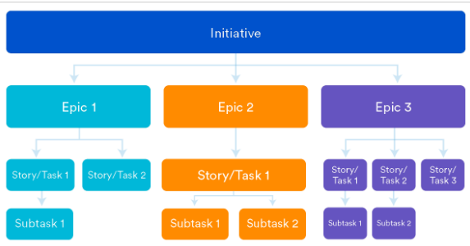

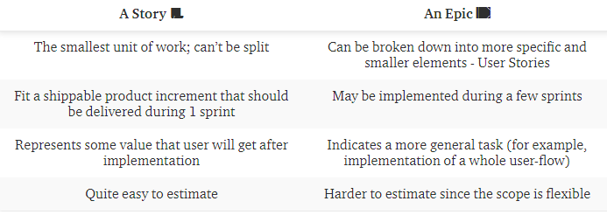

**User stories serve a number of key benefits:**

* **Stories keep the focus on the user.** A To Do list keeps the team focused on tasks,
* **Stories enable collaboration.**  team can work together to decide how best to serve the user and meet that goal.
* **Stories drive creative solutions.** Stories encourage the team to think critically and creatively about how to best solve for an end goal.

 story is written by the product owner, product manager, or program manager

During a sprint or iteration planning meeting, the team decides what stories they’ll tackle that sprint. Teams now discuss the requirements and functionality that each user story requires.

Another common step in this meeting is to score the stories based on their complexity or time to completion. Teams use t-shirt sizes, the Fibonacci sequence, A story should be sized to complete in one sprint,

**How to write user stories**

Consider the following when writing user stories:

* **Definition of “Done”** — make sure to define what that is.
* **Outline subtasks or tasks** — Decide which specific steps need to be completed and who is responsible for each of them.
* **User personas** — For Whom? If there are multiple end users, consider making multiple stories.
* **Ordered Steps** — Write a story for each step in a larger process.
* **Listen to feedback** — Talk to your users and capture the problem or need in their words.
* **Time** —Since stories should be completable in one sprint, stories that might take weeks or months to complete should be broken up into smaller stories

**User story template and examples**

User stories are often expressed in a simple sentence, structured as follows:

**“As a [persona], I [want to], [so that].”**

*As a [type of user], I want [an action] so that [a benefit/a value]*

Breaking this down:

* "As a [persona]": Who are we building this for? We’re not just after a job title, we’re after the persona of the person. We understand how that person works, how they think and what they feel.
* “Wants to”: Here we’re describing their intent —if you’re describing any part of the UI
* “So that”: how does their immediate desire to do something this fit into their bigger picture? What is the big problem that needs solving?

For example, user stories might look like:

* **As Max**, **I want** to invite my friends, **so** we can enjoy this service together.
* **As Sascha**, **I want** to organize my work, **so** I can feel more in control.
* **As a manager**, **I want** to be able to understand my colleagues progress, **so** I can better report our sucess and failures.
* As a *driver*, I want to *block badly behaved passengers* so *they are never shown me again*.
* As a *passenger*, I want to *link the credit card to my profile* so that *I can pay for a ride faster, easier and without cash*.
* As a *driver*, I want to *add photos of my car in my profile* so that *I can attract more users*.
* As a *passenger*, I want *several available drivers to be displayed* so that *I can choose the most suitable option for me*.
* At a project level  
    
  **As a**Marketing Director,  
    
  **I need**to improve customer service  
    
  **So that**we retain our customers.
* At a detailed level  
    
  **As an**Investor,  
    
  **I need**to see a summary of my investment accounts,  
   **So that** I can decide where to focus my attention.

**User Story Example:**  
 **Story Identifier:** STK001  
  
**Story Name:**Customer Order  
  
**Description:**As a Customer, I need to place an order so that I can have food delivered to my house.  
  
**Confirmation:** Acceptance Criteria examples:  
  
Functional:  
  
- Can I save my order and come back to it later?  
  
- Can I change my order before I pay for it?  
  
- Can I see a running total of the cost of what I have chosen so far?

Non-functional: availability:  
  
- Can I place an order at any time (24 hours per day or 24/7/365)?

A sprint is a fixed time period where teams complete work from their product backlog. Sprints are usually one, two, or four weeks long. At the end of the sprint, a team will typically have built and implemented a working product increment.

Update the **Sprint name** and add a **Sprint goal** if you want to, and select the **Start date** and **End date** for the sprint.